Identify potential security risks from open ports



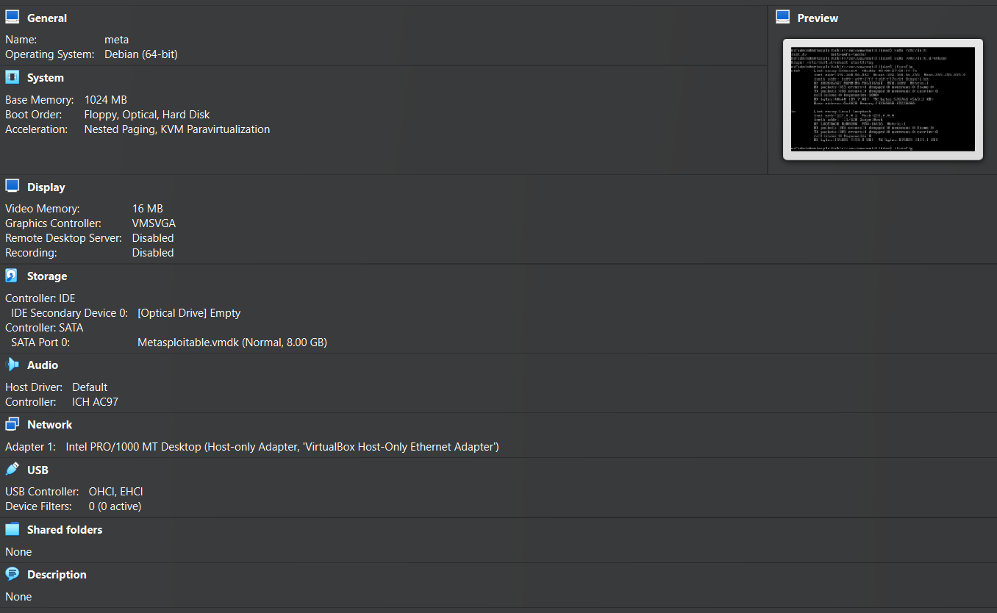

**What is SearchSploit?**

**SearchSploit** is a command-line tool that allows you to search the **Exploit Database (exploit-db.com)** for known vulnerabilities **offline**.

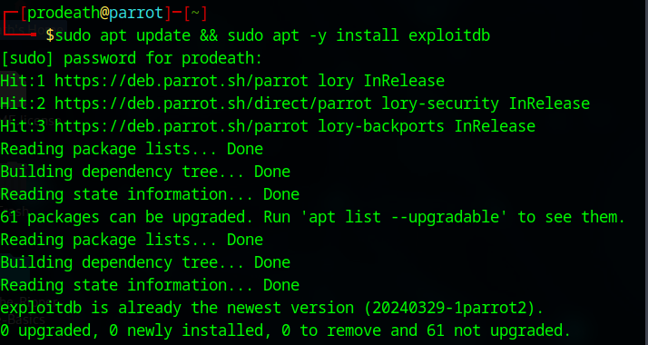

Install SearchSploit

sudo apt update && sudo apt -y install exploitdb

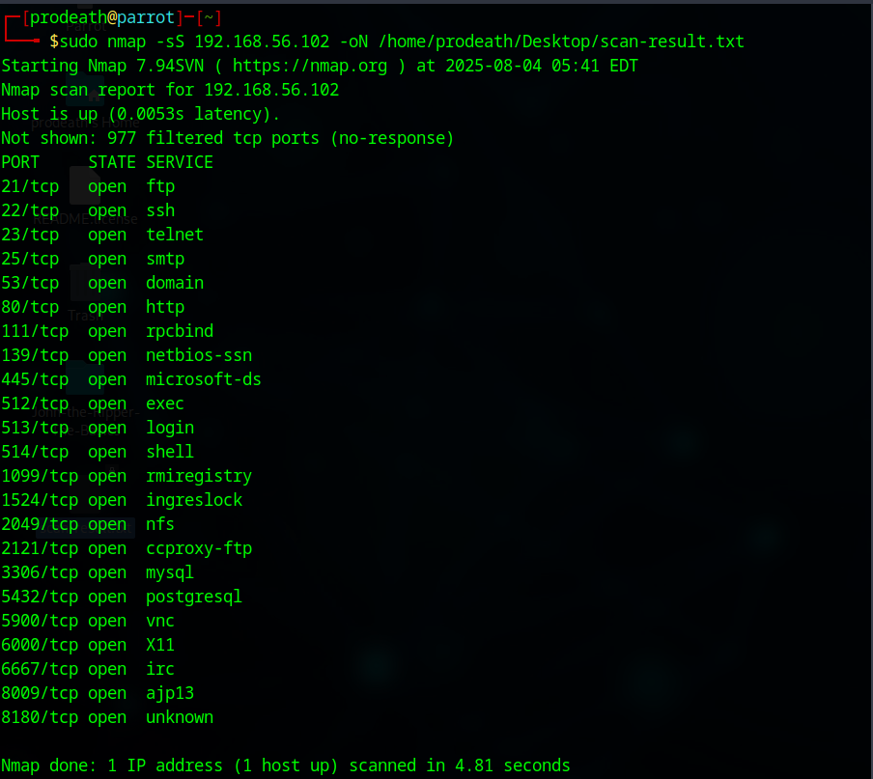

**Search for Exploits**

Use searchsploit with relevant service name and version.

